Software Requirement Specification
Table of Contents

1. Introduction
1.1 Purpose
1.2 Scope of Project
1.3 Intended Audience
1.4 References
2. Overall description
2.1 Product Perspective
2.2 User Classes and Characteristics
2.3 Operating Environment
2.4 Design and Implementation Constraints
2.5 Assumptions and dependencies
3. Requirement Specification
3.1 Functional Requirements
4. Nonfunctional Requirements
4.1 Performance requirements
4.2 Safety requirements
4.3 Security Requirements
4.4 Software Quality Attributes
4.5 User Documentation

5. External Interface Requirements
5.1 User Interfaces
5.2 Hardware Interfaces
5.3 Software Interfaces
5.4 Communications Interfaces

6. Other Requirements
Appendix A: Glossary
Appendix B: To-Be-Determined List

Revision History
Requirement ID | Date Of revision | Reason For Changes | Version

1. Introduction

  - Purpose

The Purpose of the project is to design a system which enhances the quality of medical scans and has some diagnostic capabilities in order to identify the defect. The proposed system should also retrieve visually similar images for reference.

1.2 Scope of the project

By consulting the output of this system, the physician can gain more confidence in his/her decision or even consider other possibilities. Our proposed system helps in automating the diagnosis process for set of medical scans preferably MRI scans. The system should be able to analyze approximately 16-18 images of different views, produced in one scan to give results.

1.3 Intended Audience

- Clients (doctors)
- Team
- Evaluators

1.4 References
- An Integrated Approach to Software Engineering, Pankaj Jalote, 3rd edition.

2. Overall description

2.1 Product Perspective

CBIR [1] system is different from traditional retrieval system based on text mode. Image is described by some visual features not only by text, such as color, texture, shape, space and other features. CBIR system is a system that extracts properties of the image, such as color, texture and shape to construct a Feature vector to compare query image to image in the images database.
The project aims at helping the doctors to do better analysis and can gain more confidence in his/her decision or even consider other possibilities.

2.2 User Classes and Characteristics
- Medical Students/ Doctors: practitioners from medical stream can make use of this to analyze the process involved in interpretation of scans to detect the ailment and better visualization of the scans.

  - Operating Environment

2.3.1 Hardware Requirements
Core 2 Duo processor or above
Processor speed: 1.6 GHz
Physical Memory (RAM): 2.0 GB
Disk Space: 6.00 GB
    - Software Requirements
Development OS : Windows XP/7
MATLAB 7.5 or above

2.4 Design and Implementation Constraints
- Used for standalone system. Not used in distributed systems.
2.5 Assumptions and dependencies

2.5.1 Assumption: The product uses only one type of image database.
2.5.2 Dependencies:
- Retrieval efficiency depends on image database.
- Diagnostic efficiency of the system depends on the knowledge of the assisting medical professional.

3. Requirement Specification

3.1 Functional Requirements

- The user shall be able to load a query image.
- The system shall be able to extract the features such as colour, texture and shape using the gabor filter.
- The system shall be able to transform a discrete image which is defined at one set of coordinate locations to a new set of coordinate points i.e., converting from rectangular to hexagonal grid.
- The system shall be able to enhance the scans of medical images for better visibility.
- The system shall be able to diagnose the ailment.
- The system shall be able to provide visual indication of the affected area.
- The system shall be able to provide a brief description of the problem detected.
- The user shall be able to retrieve images of similar cases for reference.

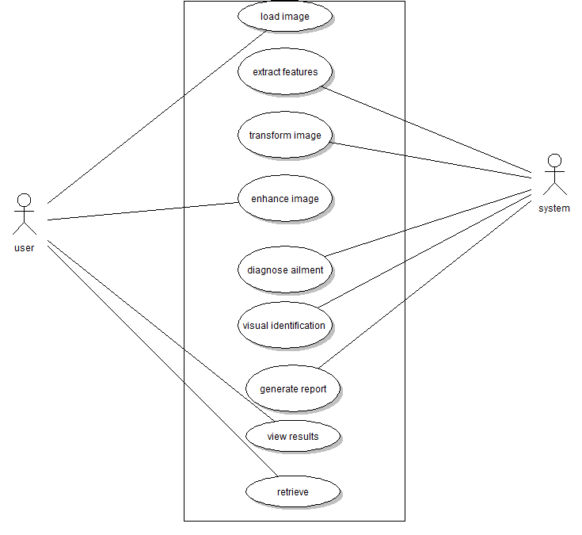
Figure 3.1

4. Nonfunctional Requirements

4.1 Performance requirements

- Response time - For any given query image, the relevant information is retrieved within 5 seconds
- Efficiency – Systems performance should be above 80%.

4.2 Safety requirements
The user should take periodic backups of the scans to prevent the loss of any data.

4.3 Security Requirements

Users will not be able to use the system without proper authentication.

4.4 Software Quality Attributes

Usability:
- The installation time of the proposed product will be less than 30 seconds.
- The user needs to go through user’s manual for understanding the operability of the system.
Modifiability:
- Image database can be extended for larger size.
- The proposed system can be modified for using over a network.

4.5 User Documentation
- User manual for understanding of the operability of the system is provided for the intended audience i.e. doctors.

5. External Interface Requirements

5.1 User Interfaces

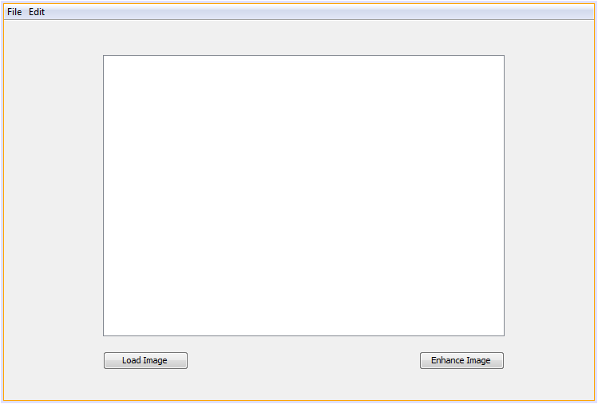
Figure 5.1.1
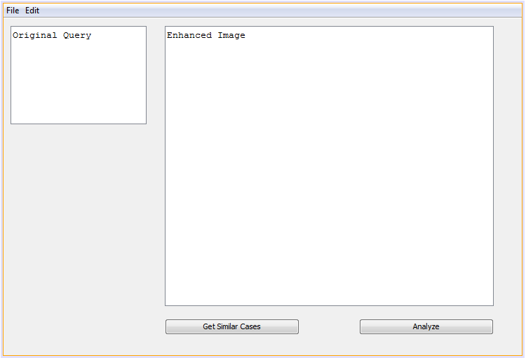
Figure 5.1.2

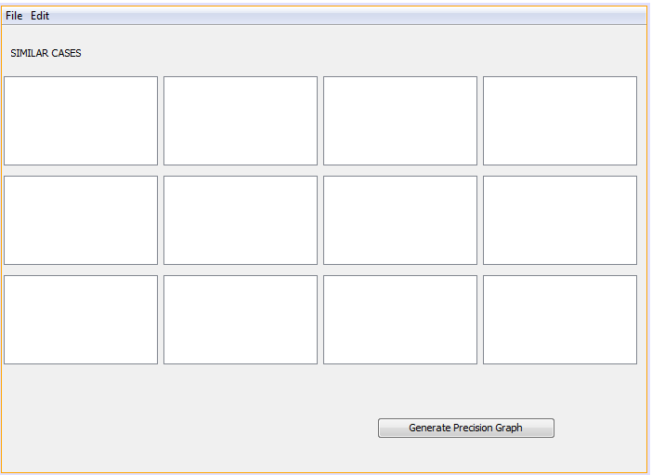
Figure 5.1.3
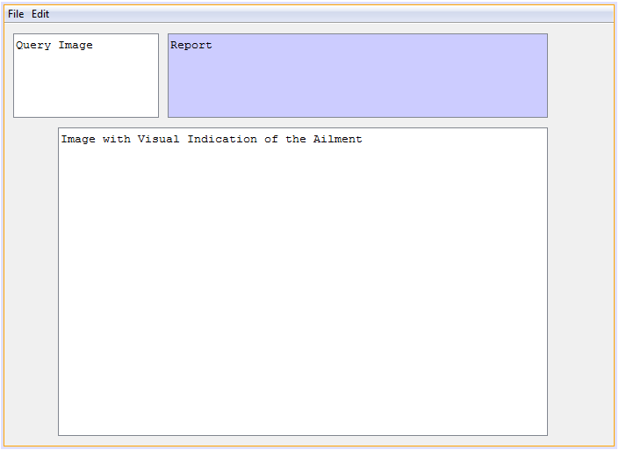
Figure 5.1.4

5.2 Hardware Interfaces
No hardware interfaces are required for the proposed system.

5.3 Software Interfaces
The scanned images are in the .dcm format. The proposed system needs the images to be in the jpg/jpeg format. Hence, a .dcm to .jpg/.jpeg image converter is required.

5.4 Communications Interfaces
No communication interfaces are required for this system.

6. Other Requirements

Approx. 200 real-time MRI scans in .dcm format.

Appendix A: Glossary

[1] CBIR: Content-based image retrieval is an application that helps in retrieving images from large databases.
[2] .dcm: File extension for DICOM i.e Digital Imaging and Communications in Medicine
Appendix B: To-Be-Determined List

Compile a numbered list of the TBD (to be determined) references that remain in the SRS so that they can be tracked to closure.

